Part 1: Activating UCI NET ID/UCI Module Process Updated Process 2026

Hello! Once you receive your ID and UCI NET ID, please complete the steps below:
- Go to https://itsneo.health.uci.edu/
- Please watch the introduction video.
- Please read the overview regarding your UCI Accounts to better understand them.
- Click the sections below in numerical order and complete.
  - Please note: After completing section #4 please allow up to 72 hours for access into UC Learning System
  - You can locate UCLC to complete UCI modules in the top right hand corner go to UCI HR Apps, and click on UC Learning Center
  - Please complete modules in Manage or Cancel My registrations tab, and modules due through the end of the following month you are currently in the Assigned Training Tab.
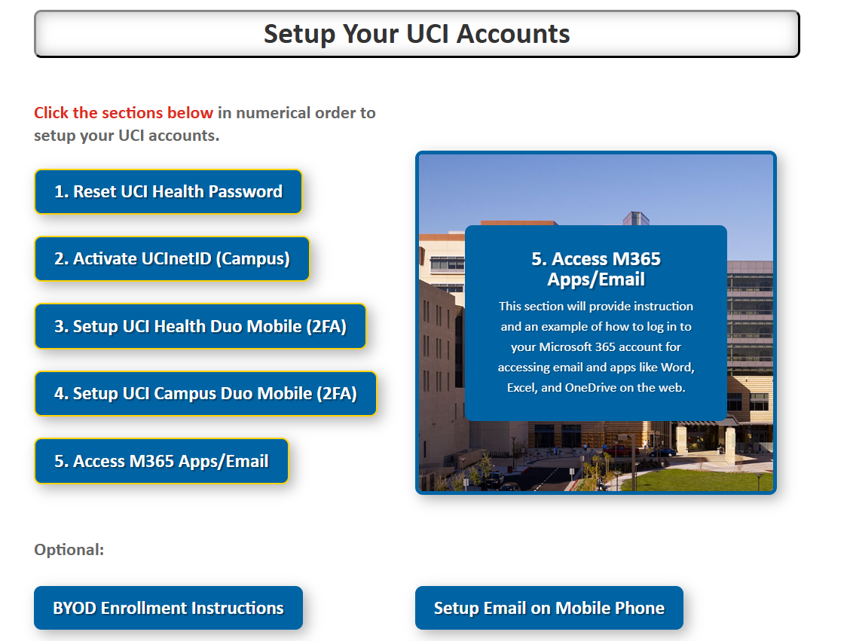

Once completed, please go to the Manage or Cancel my registration tab, click on completed, and print your transcript and send your compliance and credentialing specialist.

Once completed, your access to complete epic training in epic university will be requested by our team. PLEASE ALLOW 3 BUSINESS DAYS FOR ACCESS TO COMPLETE EPIC TRAINING

